USER EVALUATION

**1 PROCESS OF EVALUATION**

User testing was conducted with anyone who was asked to help and consented to it. Before the user testing, the participant had to read both Participant Information Sheet and Informed Consent Form, which they have also been required to fill out. Once the forms were collected, we continued with the testing.

Users were asked to participate in the testing of the website using a device and browser of their own choosing. The participants, either supervised by a researcher or on their own, were tasked with joining and playing a quiz and time allowing, they were also tasked with hosting a quiz themselves and being responsible for making sure the other participants joined the game. The researcher provided minimal direction in order to obtain the most unbiased results possible.

Users were afterwards directed to a questionnaire where the user would provide feedback from their experience during the testing of the website. Questions were focused on gauging their overall experience and identifying any potential difficulties or bugs that may have arisen during testing, with the option for the participant to expand upon this in written form.

**2 FEEDBACK OVERVIEW**

Sample size: 17 participants

|  |  |
| --- | --- |
| **Devices** | **Web browsers** |
| Desktop: 10  Mobile: 5  Unknown: 2 | Chrome: 7  Safari: 2  Microsoft Edge: 2  Firefox: 1  Brave: 1  Unknown: 4 |

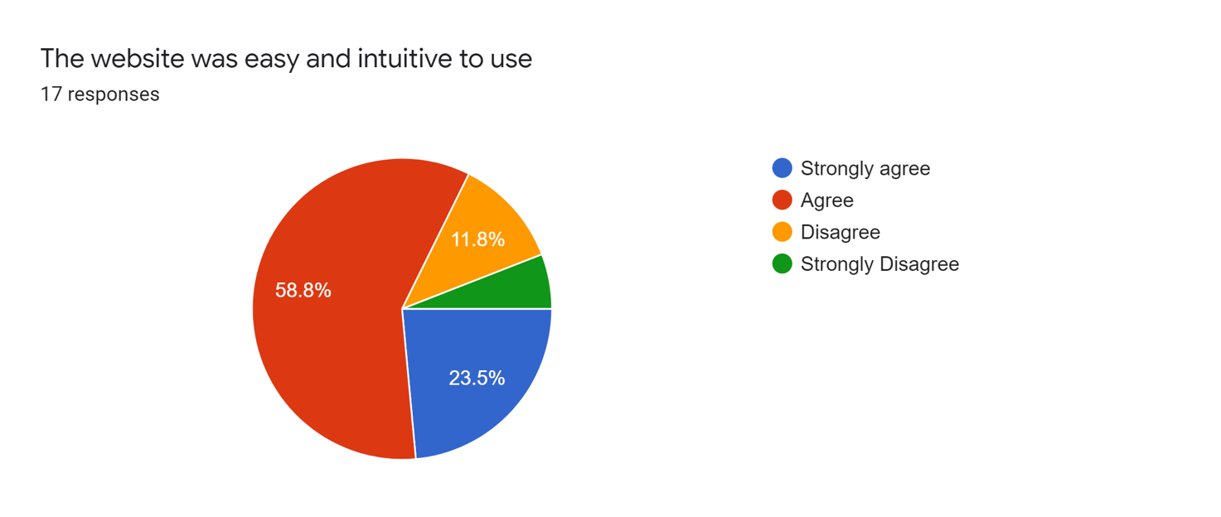

**The website was easy and intuitive to use**

As shown, the vast majority of the participants found the website easy to navigate and was not a mentally nor physically demanding task.

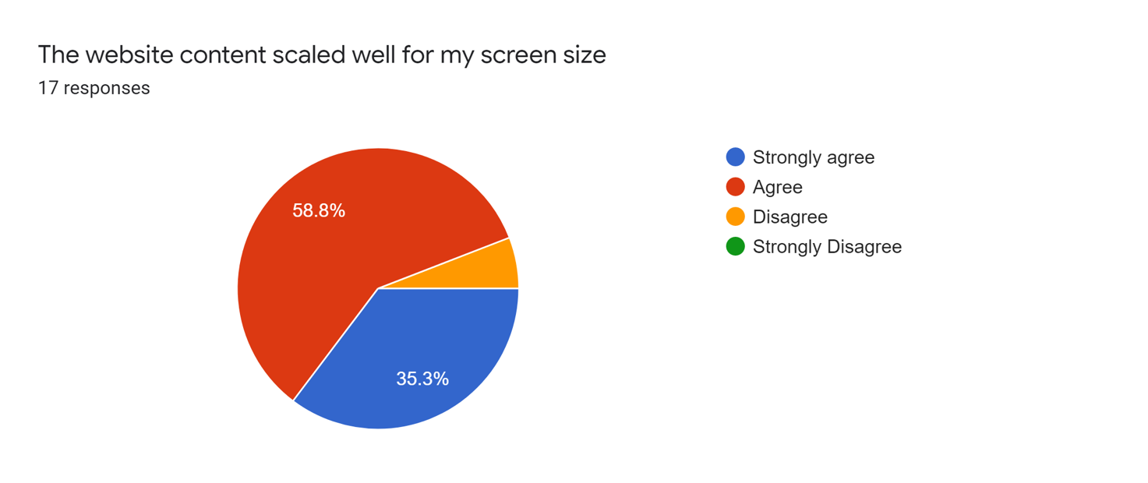

**The website content scaled well for my screen size**

Clearly, it seemed that the overall consensus was that the website was particularly adaptable to different devices. This was supported by another question which inquired about the device (and browser) that the participant used during the evaluation - of which many were mobile devices.

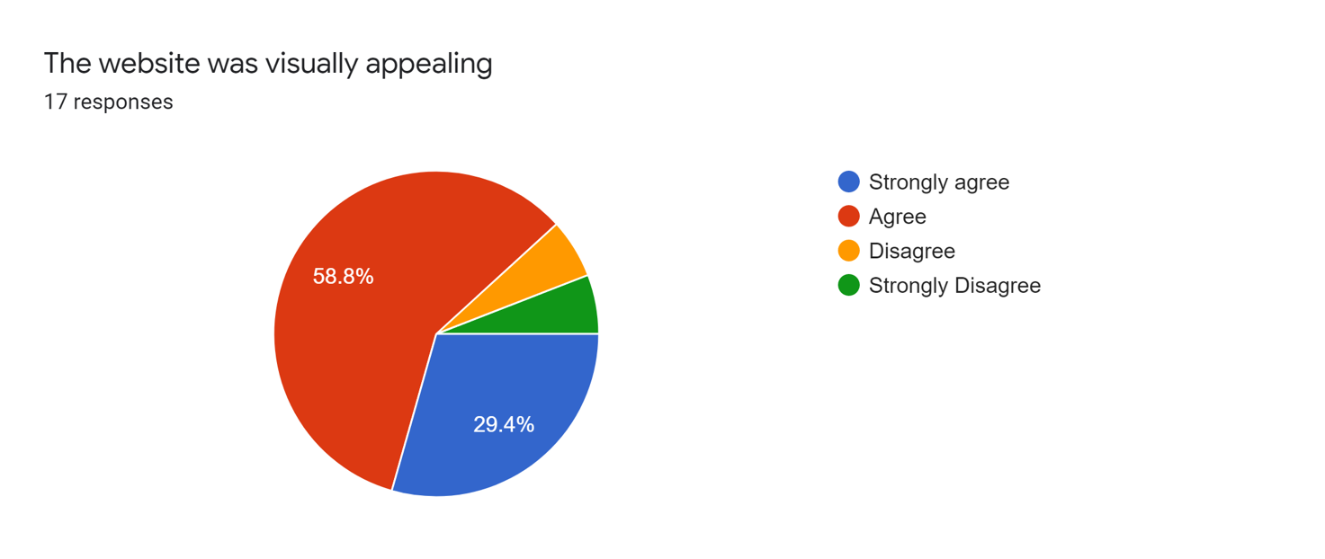

**The website was visually appealing**

As shown, most users considered the aesthetic and themes used in the design of the websites to be visually appealing, which supports the objective of making a more mature, dark-mode website.

**Main issues raised by participants**

* Several participants were confused by the scoring system (correct answer streaks contributing more points) and would have liked it to have been clearer and more obvious.
* Majority of participants wanted to see a running total of correct answers as they went along, rather than just seeing their end score after the quiz had ended.
* Some participants did not like that they could not change their answer after they had already chosen an answer, but this is something that was a design choice and forces the user to choose more wisely their answer in the first place.
* Some participants were missing the progress feedback during their quiz.
* One participant became stuck on the host page and suggested a need to add a back button in order to make navigating the website more convenient and allowing users to recover after making a mistake.
* One participant used a mobile and saw the timer placed on top of the question.
* One participant noticed there was no input validation for minimum number of seconds per question, so you could pick to have a quiz with one second timer.
* One participant said they would prefer a share button or URL link instead of the Quiz ID.

Some have also included additional features they would like to see

* One participant suggested adding a chat option while in the waiting lobby.
* One participant suggested a possibility to create a custom quiz.

**Main issues raised by team members**

We also held a session where everyone on the team played through and tested the app for 15 minutes. Some of the feedback we got from our internal testing was:

* Team members agreed that the Leave button on mobile looked too much like an answer button, it also wasn’t placed well on desktop and could have been smaller.
* Team members agreed that the leaderboard could be clearer and visually more appealing.
* Some team members said that the correct answer was on the screen for too long.
* One team member thought that the START button could have been worder better and suggested to rename it JOIN instead.

**3 IMPLEMENTATIONS**

After discussing and evaluating the feedback from participants and other team members, the frontend team decided to implement some changes that were within the scope.

* Leave button was made smaller and pushed into the bottom right corner.
* Progress was now being displayed above the question, where you could see the current question number out of total questions number (for example 2/10).
* Back to homepage button was implemented on the Host and Leaderboard pages.
* Mobile view problems were tested on several devices and resolved.
* Input validation on time per question was changed from 1-100 seconds to 5-100 seconds.
* Time of the corrected answer being shown was cut from 5 seconds to 2 seconds.
* START button was renamed to JOIN.
* Leaderboard was to be redesigned on both desktop and mobile.